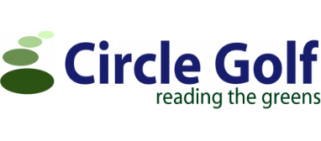
Personal Liability – Members:
The Public Liability cover arranged by the club is extended to include and respond in the first instance to an incident on behalf of any member of the club by providing an Indemnity against legal liability to pay compensation and claimants’ costs and expenses in respect of accidental:
Injury to any person and/or Loss of or damage to material property within the territorial limits set out below during the period of insurance and in connection with their golfing activities, including costs and expenses incurred with the insurers’ written consent.
Limit of Indemnity:
£5,000,000 any one occurrence and unlimited any one period of insurance
Territorial Limits:
Anywhere in the world for liability arising in respect of golfing activities.
Excesses Applicable:
Bodily Injury Excess: Nil
Third Party Property Damage Excess: £350, except when damage caused by a golf ball and the cost is under £350: Nil Excess (£1000 max per annum).
Personal Liability – Visitors & Guests:
The Public Liability cover arranged by the club extends to include and respond in the first instance to an incident on behalf of any visitor or guest to the club by providing an Indemnity against legal liability to pay compensation and claimants’ costs and expenses in respect of accidental:
Injury to any person and/or Loss of or damage to material property
within the territorial limits set out below during the period of insurance and in connection with their golfing activities, including costs and expenses incurred with the insurers’ written consent.
Limit of Indemnity:
£5,000,000 any one occurrence and unlimited any one period of insurance
Territorial Limits:
Whilst playing or utilising the facilities provided by the club.
Excesses Applicable to All:
Bodily Injury: Nil Excess
Third Party Property Damage Excess: £350, except when damage caused by a golf ball and the cost is under £350: Nil Excess (£1000 max per annum).

In the event of a claim please contact Circle Golf Claims on 0141 242 4841.

